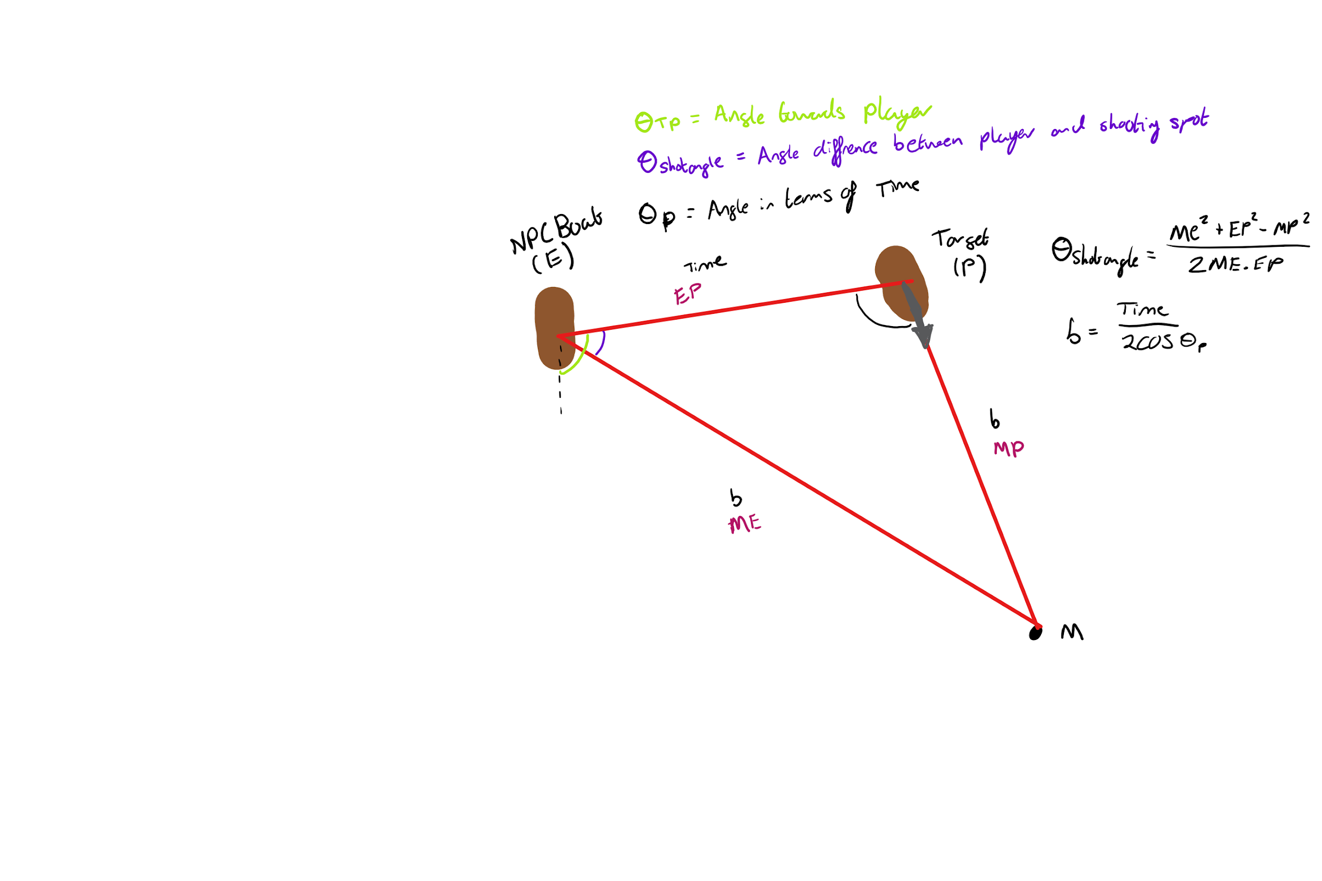

First of all this function is used to be able to find the collision point of two objects, in this case it is for the shot angle for the NPC (E) to fire and hit the Target (P). The point M is where the shot will collide with the Target. Due to it colliding with the Target we know that both ME and MP take the same time labelled as b and with simple math we know EP being just the distance between them divided by the projectile's speed that is equipped to that boat.

We first work out thetaP in terms of time which then gives us b which is the time taken for the shot. This function is timeForPerfectShotToCollide().

Knowing the stuff we do at the moment could give us an angle however due to the different speeds of the objects rather than being an isosceles in time in actual distances they could be varied. This means we convert them back into distances ME, EP and MP then work out shotAngle from there. Then we add shotAngle onto thetaTP which is the angle from the normal to the Target which then gives us the angle from the normal to M. This is where the NPC should fire for the perfect shot.